 | Greythorn Primary School  Head Teacher: Mrs Sally MacDonald  Greythorn Drive, West Bridgford  Nottingham, NG2 7GH  Telephone: 0115 914 9779  Fax: 0115 914 9778  Email: head@greythorn.notts.sch.uk  @GreythornPS | 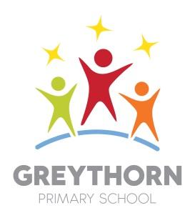
Full-time, permanent KS2 teacher and KS2 leader- with TLR2

Dear Candidates

Thank you for your interest in the role of KS2 teacher and leader at Greythorn. If you decide you would like to apply, here is a time line and an idea of what we would like to see in your application.

Monday 10th February - Job is advertised and open for application- full details available from the Greythorn office or on our web-site.

Wednesday 12th February, Friday 14th February, Tuesday 25th February, Monday 2nd March

- Visits to the school from 4pm. Please phone the school office to make an appointment.
Friday 6th March, 12 noon - Deadline for applications

Tuesday 17th March - Interviews

Your application should include the following:
- A completed application form
- A letter of no more than 2 sides of A4 in which you demonstrate your suitability and experience for the role. Please refer to the person specification in the composition of your letter.
Please do not include a CV or other materials in support of your application- in fairness to other candidates they will not be read.

Your application can be posted or emailed to the Greythorn office: office@greythorn.notts.sch.uk

If you are chosen for interview we will invite you by email by Wednesday 11th March. The interview will include an observed lesson, a work scrutiny and an interview and will take most of the day.

I very much look forward to hearing from you.

Sally MacDonald

Headteacher

