July 2019

Dear Colleague

Receptionist/Administrator

Thank you for your interest in the above post. The closing date for applications is Midday on Monday 8 July 2019 and interviews will be held as soon as possible thereafter.

To assist you in your application the following is enclosed:

- Job Description
- Application Form

If you would like to be considered for the post, your application should consist of:

- a fully completed application form (together with a curriculum vitae if that contains additional information)
- a letter of up to two sides of A4 which states clearly:
- your reasons for applying

The academy is committed to safeguarding and promoting the welfare of children and young people and expects all staff to share this commitment. The post is therefore subject to an enhanced DBS check.

If you need any further information or would like to have a look around the school, please do not hesitate to contact Mrs Ridgill, Operations Manager.

Finally, I would like to thank you for your interest in Colonel Frank Seely Academy and look forward to receiving your application.

Yours sincerely

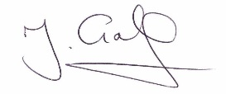

MR J GALE
Headteacher

