Castle Donington College

Teacher of Maths
Full Time
ECTs are welcome to apply
Start date: Autumn Term 2023

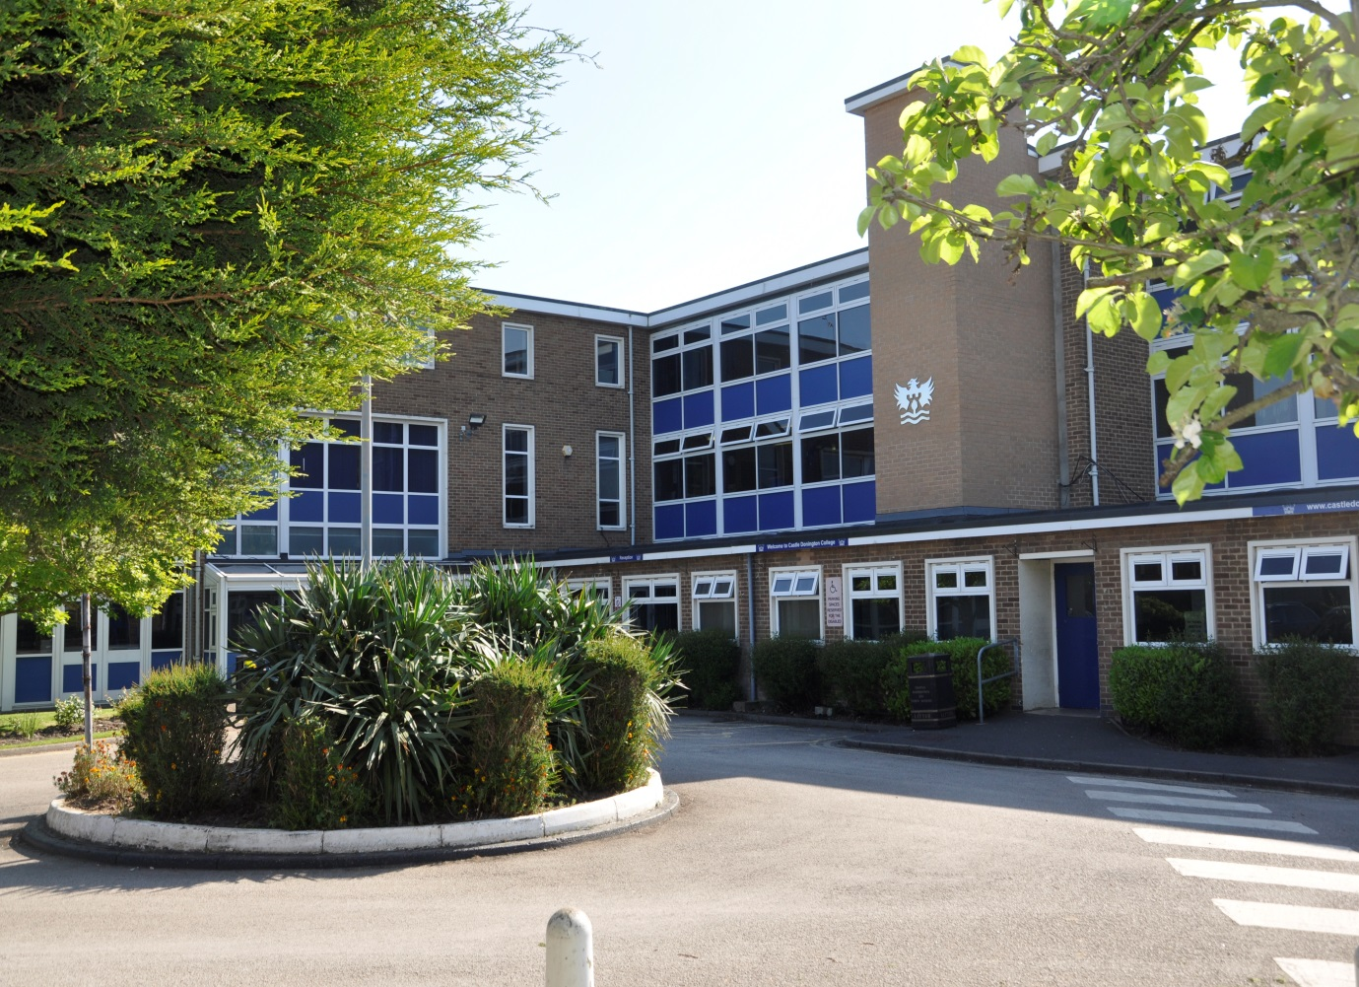

Applicants Information Pack

Dear Applicant,
Teacher of Maths
Thank you for your interest in the post of Teacher of Maths at Castle Donington College. I hope the enclosed pack will be of interest to you and I look forward to receiving your completed application. We welcome applications from experienced, recently qualified and Career Entry teachers.
Castle Donington College is a small 11-16 school. We have 650 pupils on role across five-year groups. The College is situated on the Northwest edge of Leicestershire on the Leicestershire, Derbyshire, and Nottinghamshire border and within 30 minutes’ drive of Nottingham, Derby, Leicester, Loughborough and Burton, being close to the M1 and A50.

In January 2019 we received an Ofsted rating of ‘Good’ and we are very proud of our community and the pupils we serve. We chose to join the East Midlands Education Trust, a successful and thriving partnership of high achieving schools in January 2022. We have high aspirations for everyone in our community whether pupil or staff. We are therefore seeking to appoint a teacher who has a clear desire to contribute to the future success of the College and to support our young people to become the best they can be.
Maths is a key subject within the Castle Donington Curriculum. The Maths Department is currently housed in a suite of rooms, offering the successful candidate their own teaching room. Students study Maths for four lessons a week and experience a full extra-curricular programme of clubs and activities. Maths is a well-regarded department, delivering to students in KS3 and KS4 in ability groups. We have recently introduced the Further Maths qualification for a small group of Year 10 and 11 pupils. The outcomes Maths have achieved are enviable and a result of the dedication and commitment of our hardworking team.
The successful candidate would need to be able to operate within a close, dynamic and forward thinking team. The Maths department are committed to developing challenging, engaging and exciting learning experiences for our students. The department has a passion for Maths and the successful candidate must share this enthusiasm. You will demonstrate a clear understanding of GCSE courses, whilst contributing to maintaining and developing the existing KS3 curriculum. You will be able to demonstrate impact in achieving further increases in attainment and progress for all students.
All teachers at Castle Donington College are also Tutors. The pastoral care and monitoring of progress of students is an essential part of the teacher’s role.
All our staff have the highest expectations of themselves and the students. They work closely to share best practice and drive school improvement. In a recent staff survey 100% of respondents said that Castle Donington College was a good place to work.
We are committed to a happy, purposeful and secure environment that provides the opportunity for all to grow and develop. Our teachers are highly valued, well regarded and fully supported. We can offer a coherent programme of induction and we have a strong commitment to professional development through our Professional Learning Programme. Your development will be a key priority for us, regardless of your experience.
The job description and person specification will give you further details about what we require. We welcome and encourage prospective candidates to come and visit, to meet our staff and pupils and to experience first- hand the ethos and values of the College. If you believe you have the skills and qualities to help us continue to be successful, then I look forward to receiving your application. Details of how to apply can be found overleaf.
We welcome and encourage prospective candidates to come and visit, to meet our staff and students and to experience first- hand the ethos and values of the College.
Appointment of | Teacher of Mathematics
Closing Date for Applications | 17th April 2023
Interview Date | tbc
Start Date | Autumn Term 2023

To apply:

- Download an application form from East Midlands Education Trust website www.emet.uk.com/vacancies
- On the application form, please focus on a detailed 'supporting statement' considering the person specification and indicating why you would be the best person for us to recruit to this position.
Set out your experience to date and what you feel you can contribute to the post; include information about your current expertise and experience.
CVs will not be accepted.
- Please send completed applications forms to recruitment@emet.uk.com by the closing date

Castle Donington College is committed to safeguarding and promoting the welfare of children and young people and expects all staff and volunteers to share this commitment. Safeguarding checks will be undertaken during the recruitment process.

We welcome applications from all who feel they have the qualities to contribute to this School regardless of age, gender, ethnicity or religion.

Please be aware, as the applicant, you are responsible for ensuring your application reaches us before the deadline/closing date. Late applications will not be accepted.

Person Specification- Teacher of Maths
 | Essential / desirable
Qualifications
Qualified to degree level and/or above | E
Qualified to teach in the UK | E
Qualified teacher status in Maths | E
Right to work in the UK | E
Right to work in the UK | E
Experience and Knowledge
Knowledge of and recent teaching of Maths at KS3 and KS4 | E
Experience of teaching Maths at KS5 | D
Experience of teaching in more than one school | D
Understanding of Maths curriculum and assessment at KS3 and KS4 | E
Understanding of role regarding safeguarding and child protection | E
A proven track record of excellent outcomes for students | E
Teaching and Learning
Excellent classroom practitioner | E
Willingness to implement strategies to improve and sustain the highest quality of education | E
Strong communication, planning and organisational skills | E
Ability to apply highly effective behaviour for learning strategies | E
Ability to demand high standards, using flair and creativity to engage and enthuse students | E
Ability to challenge students of all abilities, needs and backgrounds. | E
Effective organisational skills including the ability to meet deadlines | E
High expectations for accountability and consistency | E
Ability to work independently and as part of a team | E
Commitment to promoting innovations that raise students’ levels of attainment and progress | E
Skills and attributes
A positive outlook, well-motivated, enthusiastic and energetic | E
Commitment to own professional development | E
Professional appearance and manner | E
Work in ways that promote equal opportunities | E
Self-awareness, empathy, ability to manage feelings, motivation and social skills | E
The ability to influence and motivate others in a positive way | D
Commitment to supporting the full life of the school | D
Excellent health and attendance record | E
Able to demonstrate resilience, motivation and commitment to driving up standards | E

Job Description: Teacher of Maths

Job Title: | Teacher of Maths | Reporting to: | Head of Department
Department: | Maths | Line Managing: | -
Post Type | Full time

Safer Recruitment Statement
Castle Donington College is committed to safeguarding and promoting the welfare of students and young people and expects all staff and volunteers to share this commitment. This post is designated as a Regulated Activity and the post holder will be subject to an enhanced DBS disclosure check.

Responsibilities of all teachers:
- To have an understanding of and always act within, the statutory frameworks which set out your professional duties and responsibilities.
- Treat all pupils with dignity, building relationships rooted in mutual respect and at all times observing proper boundaries as appropriate to their professional role within the College.
- Having a regard for the need to safeguard pupils’ well-being in accordance with statutory provisions. To ensure all pupils are safe at all times.
- Show a tolerance of and respect for the rights and beliefs of others.
- Not undermining fundamental British values, including democracy, the rule of law, individual liberty and mutual respect and tolerance of those with different faiths and beliefs.
- Ensuring that personal beliefs are not expressed in ways that exploit pupils’ vulnerability or might lead them to break the law.
- To have proper and professional regard for the ethos, policies and practices of the College and maintain high standards in your own attendance and punctuality.
- To make the education of pupils your first concern.
- To be accountable for achieving the highest possible standards in work and conduct.
- Act with honesty, integrity and work in the best interests of the pupils at all times.

All teachers will:
- Encourage good progress and outcomes
- Demonstrate good subject and curriculum knowledge
- Plan and teach well-structured lessons
- Adapt teaching to respond to the strengths and needs of all pupils
- Make accurate and effective use of assessment
- Manage behaviour effectively to ensure a safe and productive learning environment
- Fulfil wider professional responsibilities
- Keep themselves and others safe

Responsibilities of a Teacher at Castle Donington College, Specific to the post
All teachers have a responsibility to inspire and engage pupils to demonstrate a passion for your subject, continuously improving classroom practice and achieving excellent outcomes for all pupils by:
- Ensuring teaching, behaviour and outcomes are good or better in your lessons
- Demonstrating excellent subject knowledge
- Adapting your teaching to respond to the strengths and needs of all pupils
- Participating fully in the College’s quality assurance programme in order to raise standards
- By sharing best practice internally and externally to ensure the quality of teaching is good or better
- Ensuring all pupils engage and make progress by making effective use of the available data to plan and deliver engaging lessons
- Making effective use of resources for learning and using the latest technologies for learning to ensure best pupil outcomes and experience
- Ensuring that all pupils in your lessons achieve at least expected levels of progress and a high proportion exceed them
- Identifying, tracking, analysing and responding to data in relation to reporting on outcomes, to ensure that the highest outcomes possible are achieved
- Contributing to the creation of schemes of work that challenge, stretch and fire the imaginations of our pupils
- Challenging pupils by ensuring behaviour strategies are followed consistently in line with College procedures
- Ensuring that incidents of poor pupil behaviour are successfully dealt with to minimise disruption to learning
- Carry out appropriate duties and participate in meetings as defined by the relevant rota and calendar
- Personally and collectively support pupils in becoming confident individuals, successful learners and responsible citizens
- Respond speedily to parental concerns
- Act as role models by demonstrating a professional level of dress, appearance and behaviour.
- Treat all colleagues with respect
- Engage actively in the Performance Management process
- Be expected to comply with any reasonable request from a manager to undertake work at a similar level that is not specified in this job description
- Be a form tutor

This job description sets out the duties and responsibilities of the job at the time when it was drawn up. Such duties and responsibilities may vary from time to time without changing the general character of the duties or the level of responsibility entailed. Such variations are a common occurrence and cannot in themselves justify a reconsideration of the grading of the job. This job description is current at the date shown, but following consultation with you, may be changed by the Principal to reflect or anticipate changes in the job which are commensurate with the salary and job title.
March 2023

