July 2019

Dear Applicant

Teaching Assistant

Thank you for your interest in our recent advertisement for the above post at Park Vale Academy.

If you would like to apply for the post, please send your letter of application to Human Resources, Redhill Academy Trust, HR Shared Services, William Lee Centre, Flatts Lane, Calverton, Nottingham, NG14 6JZ, or by email to hr@redhillacademytrust.org.uk clearly demonstrating your suitability for the role, together with the completed application form, to arrive before midday on Wednesday 17 July 2019. Please ensure that the post for which you are applying has been stated clearly on the application form.

Due to the number of applications we receive, it is with regret that we cannot respond to every application. Therefore, if you do not hear from me within six weeks of the deadline, please assume that, on this occasion, your application has not been successful.

I look forward to receiving your application.

Yours faithfully
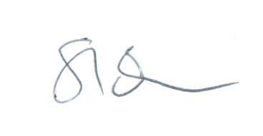
Steve Bowhay
Head Teacher

